English Texttranslation Club Magazine april 2015

From the chairman
We decided that we were going to focus on maintaining the Trintel and Trintella fleet during the Members’ meeting in November last year. We agreed to do this – besides meeting and having a good time together – in name of the association.
We are going to start by taking preventive measures. We are going to approach owners – members or not – and inform and advise them about their ships in general, the maintenance and sailing techniques. We believe that an ounce of prevention is better than a pound of cure. We will explain that later on in the newsletter.
What if it is too late for prevention?
We are going to try to talk to the owner about the problem and see if we can help. It is, however, much easier said than done.
I noticed a Trintella Ia in the harbour on the Oosterschelde last summer. I believe it had been left to the elements without any kind of cover for at least a year. We know the name of the boat, the construction number and its home port. We needed the harbour master for the name of the owner. He – rightly so – did not want to give us any private information about his members. He did agree to tell the owner that I wanted to contact him. I am not convinced that he will because the silence has been deafening since that day.
More than half a year has come and gone. The harbour master will not help me out at all even after repeatedly telling him of my intentions. I can do nothing else but wait.
This is an example of how hard it can be.
I have to try and find another way of contacting the owner.
Anyhow, I will keep you posted on my experiences.
We are going to enjoy the oncoming sailing season immensely!

Loet Geldhoff

From the committee

Let’s chat about what is going on at the moment:
The spring meeting of 2015
The Ascension weekend is in the third week of May this year. It leaves us with plenty of time to get our boats ready. Jim and Rita ten Have (Kronos, Trintella III) are our host and hostess respectively.
They will talk about the programme in great detail further along in the newsletter and the forms to sign up for the programme are enclosed.
We think it is very important that all of our members – including the ones without a boat – can join in on the meeting for one or more days. That is why we have decided that we would like to stay in one place. We liked the meeting in Hellevoetsluis last year a lot, but we were unable to plan everything in the same place this year. We will stay in the Amsterdam Marina for the first two days. However it is easier, more practical and a lot of fun to close off in Muiden, because the regatta is on the Markermeer on Saturday.
We would like to invite many classics – Trintels and Trintellas I(a) and II(a) – to participate again this year.
Now all we need is good weather.
Maintaining the fleet
Members agreed with our motion to pay attention to maintaining the Trintel and Trintella fleet, the the Members’ meeting in November last year.
Committee member Willem de Graaf is responsible for the execution and is taking up the organization and activities with vigour. He will give us some insight elsewhere in the newsletter.
The autumn meeting 2015
This is going to take place in Kampen, Overijssel, the Netherlands on Saturday 21 November. Hans and Monique Wijnants (Anne, Trintella III) are our hosts. They have already started preparing an interesting and convivial programme.
The Trintella Friends’ association flyer
We have enclosed a couple of flyers with the newsletter. We would like you to stick them to every Trintel or Trintella that you come across anywhere in the world. They are meant to invite new members to join us. We have invitations to sign up for our association in three different languages. New flyers can be ordered via our secretary.
The jubilee book
We have sold 80% of the first 500 editions at the moment and the purchases steadily continue. Don’t wait too long if you wish to order one or more copies. You can order the book, using the order-form on the website or send an email to our secretary; p.vanderwaa@trintella.org.
Picture book
We are looking for options to upgrade our picture book to a more contemporary style. This is why we have turned our attention to the possibility of a group account on Facebook. We need to take a good look at privacy, chat options, organizing the account, establishing rules and support for members who wish to create an account and use Facebook.
We will make a proposal at the Members’ meeting in November.

The Trintella Friends’ Association’s shop
Yvonne will change and/or expand the range of products. For this year she chose to do this with Trintella Friends’ towels and, for the (grand)children, sweaters and polo shirts with the Trintella logo. You are able to purchase these goods during the spring meeting or via y.slikkeveer@trintella.org.

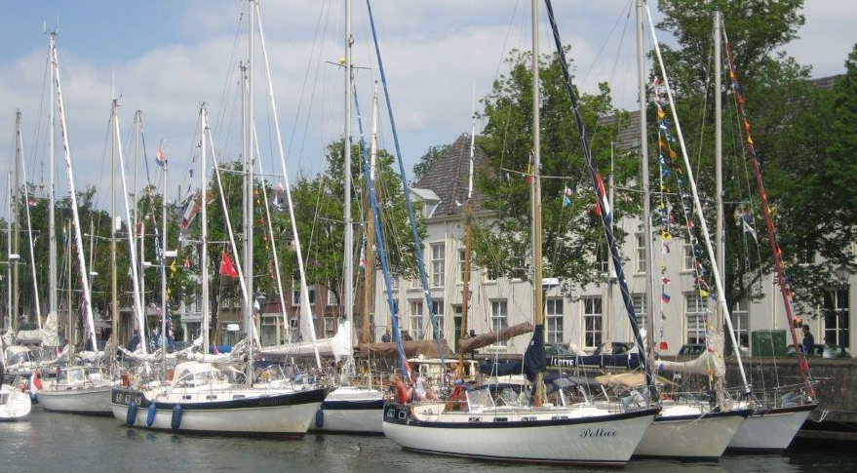

The spring meeting is upon us; from 14 until 17 May!

From Amsterdam to Muiden

The meeting will be held in the capital this year. More specifically in the Amsterdam Marina on the IJ. The Regatta is on the Markermeer on Saturday. That makes it practical and fun to end in Muiden. Our hosts are Rita and Jim Ten Have (Kronos, Trintella 3)

The programme of the meeting
We will arrive in the Amsterdam Marina during the afternoon on Thursday 14 May. We will moor on the half circle dock around the harbour restaurant ‘ Loetje aan het IJ’ (any resemblance to your chairman is a coincidence).
We welcome everyone with a drink on the dock at 16.30. The Walking dinner – with welcome and announcements – starts in the upper hall of the restaurant at 19.00

We are going to go out into Amsterdam on Friday 15 May. Rita and Jim have organised two possible excursions for us; a visit with tour guide in the Maritime museum in the morning and the ‘ Paleis op de Dam’ (palace on the dam) in the afternoon.
Everyone will have to pay their entree fees there. The annual museum pass is valid. It is possible to visit both attractions for anyone who is interested. We cross the IJ with the (free) ferry to the central station and we will either walk from there or take a tram. The evening is free for everyone to do as they please.

The regatta will be held on Satuday 16 May. It is going to be led by Frans Slikkeveer again. He is going to inform us during the conference on the dock about the set ups and rules of the game. We will leave through the Oranjesluizen (orange locks) and the Schellingwouderbrug (Schellinwouder bridge) in convoy to the Markermeer to start the regatta, at 11.00.
We will sail for Muiden after we finish and moor at the Royal Dutch sailing and rowing association KNZRV).
We will go for a drink and hold the award ceremony in the ‘Herenkamer’ (gentlemen’s room) of ‘Eethuys Café Graaf Floris V’ (diner and cafe of Count Flois V). We will close off the spring meeting there with a lovely buffet style dinner.

It is possible to visit the Muiderslot (castle of Muiden) on your own the next day.

The Amsterdam Marina and, respectively the KNZRV, offer a 10% discount on the owed fees for mooring to whomever wish to; either moor their boat the weekend before Ascension, or those who wish to pick it up the weekend after Ascension. Please fill in the application form accordingly and pay via the form as well. You do have to make your own reservations in the harbour of your choice.
Members who do not have a boat are, of course, very welcome to join us again for one or more days this year. It is possible to join us in Amsterdam on Friday. We offer a fun-filled programme for both (grand)children and adults that day. You could also join us in Muiden on Saturday!
Accommodation in Amsterdam – definitely in the Ascension weekend – is in short supply and expensive. We advise you to book your hotels well in advance, for instance near Muiden. We have opted for a couple of two person’s huts on the Vertigo in a nicely restored cargo ship on the Oosterdok for those who feel that price is more important than comfort. This ship is located on walking distance from the station. You can book on www.slaapschepen.nl.
Many classics again!
We would like to invite the classics (Trintels and Trintella I(a) and II(a)) to participate again. If you cannot make it on Friday, at least try to participate in the regatta on Saturday. Last year, a total of 10 classics out of 30 participating boats sailed. We will, naturally, have to try to top that this year! We will also make it extra attractive for you to join in. The details will follow soon, but please mark the date on your calendars.

In convoy: easy and convivial!
We are organising another convoy from the south this year. It simplifies the journey there and it is always a lot of fun. We will try to organise convoy from the north as well if there are many participants.
Frans Slikkerveer is the one to go to with your questions about the convoys: +31610931336 of fslikkerveer@hotmail.com

Please watch the Trintella website for more information: www.trintella.org.

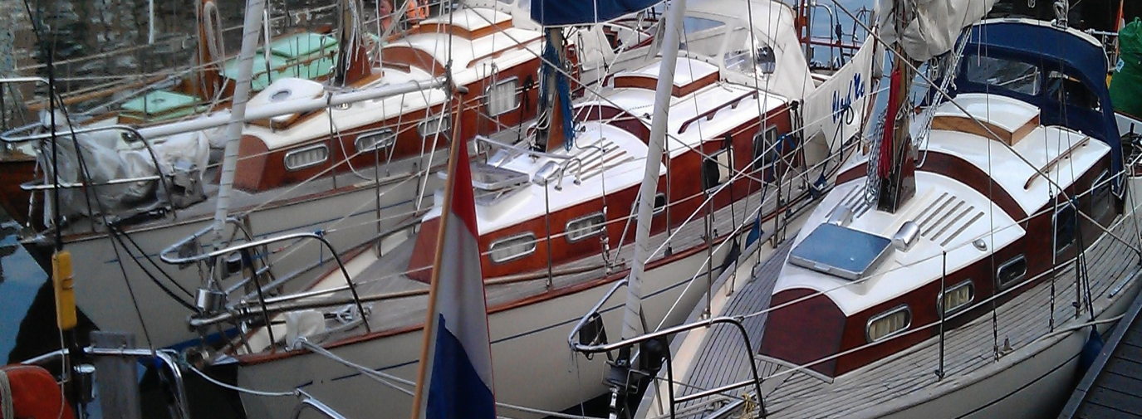
Trintella Friends’ Association to Maritime ‘s Hertogenbosch

The twentieth edition of Maritime ‘s Hertogenbosch takes place on 18, 19 and 20 September 2015. The organisers have asked the Trintella Friends’ Association to make an appearance due to the historical binding of the Trintella ship yard with the city.
It will primarily be about the classic models of the boats, judging by the nature of the event, but her modern models are welcome too.
Maritime ‘s Hertogenbosch
Maritime ‘s Hertogenbosch is the largest historic maritime navigation event of the Netherlands and takes place in the maritime heart of ‘s Hertogenbosch once every two years. The city is entirely consumed by ships for at least three days. The largest collection of classical and traditional inland navigational ships can be admired and the city centre is bustling with activities.
We will be able to enjoy open air concerts, maritime demonstrations, a Shanty choir festival, the seamen song contest, a market fare, special attractions for youth and the culinary delicacies that go with ships.
Enrol for Maritime 2015
The Trintella Friends’ Association has accepted the invitation to take part in the three day festival. We will ask the organisers for possibilities to get as many of our Trintellas close together.
You can enrol on www.maritiemshertogenbosch.nl.
Participation is free for Trintella members with ships from the classic series and it is only €20 for owners of ships from any of the other series. All participants will have free moorage on 18, 19 and 20 September and will receive the unique year pennant and plaque, and an invitation to the costumed skippers’ ball on Thursday evening.
The committee.

Maintaining our boating heritage

The Association is, besides its current activities, going to focus a lot of its attention on supporting Trintel and Trintella owners to get their boats back into a well-maintained state. The need for good maintenance is evident: the two boats in the pictures above are both from 1966 with sequential construction numbers. They portray both extreme ends of maintenance.
The nearly 1200 Trintels and Trintellas that have been built on the Anne Wever ship yard are wonderful and sturdy boats. The boats can remain amongst us for many more generations, provides that their subsequent owners use and maintain them well. The oldest part of the fleet; the Trintels and Trintellas I(a), II (a) are a joy to the eye but very vulnerable due to the amount of wood used in their construction.

It is important to frame the existing fleet as well as possible. That enables us to support a lot of owners with technical information, advice and our own experiences.
- The largest category are the ‘classics’; with over 600 Trintels and Trintellas I(a) and II(a). These boats are the most vulnerable of the bunch. We know the names, construction numbers, moorage and owners of only 10% of these boats!
- The category ‘Center Cockpits’; including the Trintellas III, IIIa, IV, 41 and V. There are about 315 boats in this group and we know about at least a quarter of them.
- The category ‘Flush Decks’; including the Trintellas 38, 44, 45 and 53. There are over 100 boats here and we know of about a quarter of these boats as well.
- Next are the Trintella 42 and the A and C series, who, together, add up to about 100 boats. We do not know a lot about these boats at all.

My request to all members is to help us frame the fleet; name, type, construction number, moorage/flag, if possible, the owners and an appraisal of the state of the boat. The latter is especially important for the Classics.
Your information will help us complete the database. It will also help us determine whether or not we need to take action and if this is possible or not.
You can send any information you have to W. de Graaf, Meestoof 198, 4331 VE Middelburg, the Netherlands. It is also possible to send an email to w.degraaf@trintella.org.

Thank you very much in advance. We will keep you informed via the website www.trintella.org.

